A WAY OF THE CROSS
10 April 2020

Background
The fourteen traditional Stations of the Cross are stopping-points in the story of the journey from the condemnation of Jesus to his death by Pontius Pilate. These stations have changed somewhat over the centuries. What it shows is that it helps people to put stopping-points or chapters into any story of devotion and meaning. This helps us to put ourselves at the heart of a text, or in an unnoticed corner of the story or in an ignored point of view. If we do this personally with a gospel story, we engage in dialogue with the text and prayer emerges. We encounter the heart and the place where the wisdom we didn’t know we had, can greet us, and so we can greet God (Padraig Ó Tuama).

This Good Friday Way of the Cross consists of five stopping points or stations in the story of Jesus’ last hours. Each stopping point has:
- a visual image;
- a reading from the Bible;
- a reflection, prayer or poem;
- a time of silence and
- a link to suggested music.

As you travel this journey, we invite you to use whichever of the resources meet your needs. You may want to follow the journey to all five stations, or you may prefer to choose one or two. You may also want to include a meditative walk in between each station, in your home or garden, or even create physical stopping-points for each station. We encourage you to be co-creators of a para-liturgy that is meaningful to you.

This Good Friday as we all struggle to come to terms with the Corona pandemic and the fears, the suffering and the death it is causing, may this very old liturgical practice of The Way of the Cross offer you a way of being with your own and others’ suffering at this time.

Introduction
Jesus reveals the depth of love and wagers his very life for the reality of the premise he has staked his whole ministry on: that love is stronger than death — love is the strongest power in the world — stronger than fear — stronger than hatred — stronger than division — stronger than violence. This is the moment, this week, when we again have the opportunity in a very special way to enter into this mystery of love with him, confront our own fears and shadows, and emerge as shareholders in his resurrection — not only through faith but through our own lived experience. (Cynthia Bourgeault, The Epicentre of Christianity is Love)

Opening prayer
O Holy One,
At this time of coronavirus and lockdown we know pain and suffering - our own, and that of our families, our country and our world. We know too that you are right inside this suffering with us.
Grant that as we walk this Good Friday journey with you and as we lament and cry out, so too we may know that you hold us in your great arms of boundless love.
Amen

STILL
For Good Friday

This day
let all stand still
in silence,
in sorrow.

Sun and moon
be still.
Earth
be still.

Still
the waters.
Still
the wind.

Let the ground
gape in stunned
lamentation.

Let it weep
as it receives
what it thinks
it will not
give up.

Let it groan
as it gathers
the One
who was thought
forever stilled.

Time
be still.

Watch
and wait.
Still.
[Jan Richardson]
FIRST STOPPING POINT - JESUS IS CONDEMNED

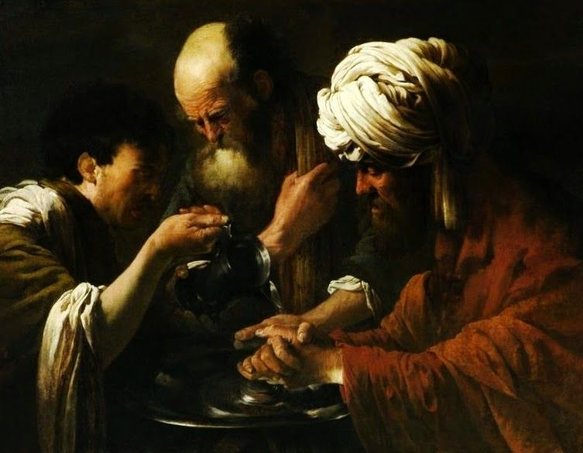
Hendrick ter Brugghen – Pilate washing his hands. Obtained from https://commons.wikimedia.org/wiki/File:Hendrick_ter_Brugghen_Pilate_Washing_his_Hands.jpg

Scripture
Then Jesus was arraigned before Pontius Pilate, the governor who questioned him. “Are you the King of the Jews?”
Jesus replied, “You say that I am.”
Yet when Jesus was accused by the chief priests and elders, he made no reply. Pilate said to Jesus, “Surely you hear how many charges they bring against you?” But Jesus did not answer Pilate on a single count, much to the governor’s surprise.
Now, on the occasion of a festival, the governor was accustomed to release one prisoner, whomever the crowd would designate. At the time they were holding a notorious prisoner named Barabbas. So when the crowd gathered, Pilate asked them, “Which one do you wish me to release for you? Barabbas? Or Jesus, the so-called Messiah?” Pilate knew, of course, that it was out of jealousy that they had handed Jesus over.
While Pilate was still presiding on the bench, his wife sent him a message: “have nothing to do with that innocent man. I had a dream about him last night which has been troubling me all day long.”
But the chief priests and elders convinced the crowds that they should ask for Barabbas, and have Jesus put to death. So when the governor asked them, “Which one do you wish me to release for you?” they all cried, “Barabbas!” Pilate said to them, “Then what am I to do with Jesus, the so-called Messiah?”
“Crucify him!” they all said. “Why? What crime has he committed?” Pilate asked. But they only shouted louder, “Crucify him!”
Pilate finally realized that he was getting nowhere with this – in fact, a riot was breaking out. Pilate called for water and washed his hands in front of the crowd, declaring as he did so, “I am innocent of this man’s blood. The responsibility is yours.” Matthew 27: 11-24

Reflection
Using the painting or the Gospel reading, think about the following:
- Who would you be in this picture or story?
- What can you see? Hear? Smell? Touch?
- What are you doing?
- What emotions do you feel?
- What do you want to say to God about this experience?
- What happened to truth and justice when Pilate washed his hands of the whole affair?
- What happens to truth and justice when we do the same?

Time of silence

Suggested music: Miserere mei, Deus by Gregorio Allegri
https://www.youtube.com/watch?v=H3v9unphfi0

SECOND STOPPING POINT - JESUS IS TORTURED

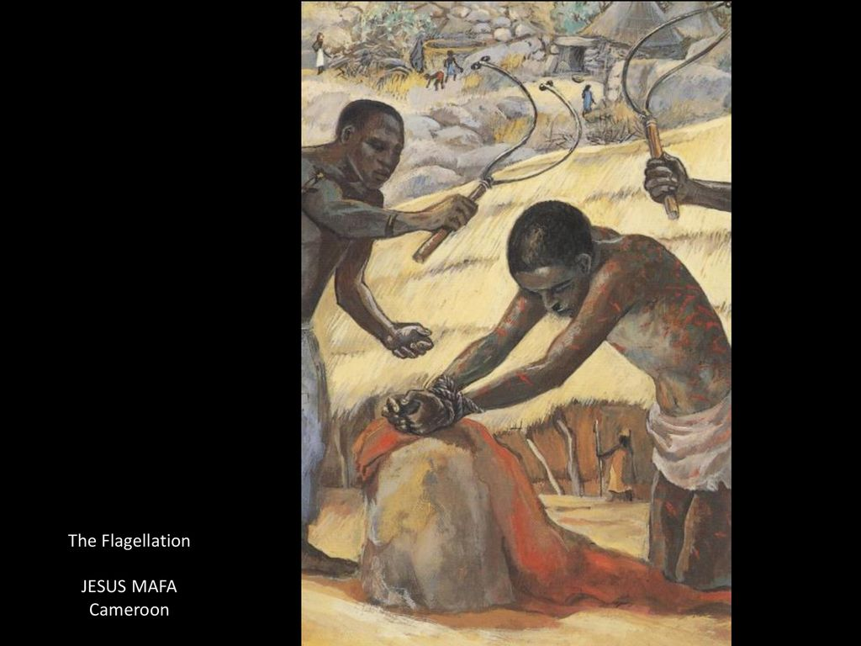
Painting by the Jesus MAFA collective in north Cameroon. Obtained from https://liturgy.co.nz/resources-for-ordinary-week-24

Scripture
I offered my back to those beating me, offered my cheeks to those who would humiliate me;
I did not hide my face from insults or spitting. Because Exalted YHWH helps me, insults cannot wound me, for I have set my face like flint, because I know I will not be put to shame.
Even as the crowds were appalled after seeing you- you were so disfigured as to no longer look human.

Though treated harshly, you bore it humbly and never opened your mouth. Like a lamb being led to slaughter, or a sheep before shearers, you were silent and never opened your mouth. Isaiah 50: 6-7; 52:14; 53:7

Reflection
Rendered powerless by those with weapons and might, Jesus was brutally tortured and violated. What agony for those who loved him to witness such cruelty.
How often have we watched the horrors of our world unfold, and stood by helpless to make it better?
How often does the brutality threaten to overwhelm us?
May we never become inured to violence and the pain in our world, or abandon our desire for peace. In confronting our fears and shadows, may we hold on to this love, “love [that] is stronger than death — love is the strongest power in the world — stronger than fear — stronger than hatred — stronger than division — stronger than violence.” (Cynthia Bourgeault)

Time of silence

Suggested music: From Händel’s Messiah

And with his stripes we are healed
https://www.youtube.com/watch?v=ftDUFFZk_so

THIRD STOPPING POINT - JESUS REACHES OUT FROM THE CROSS

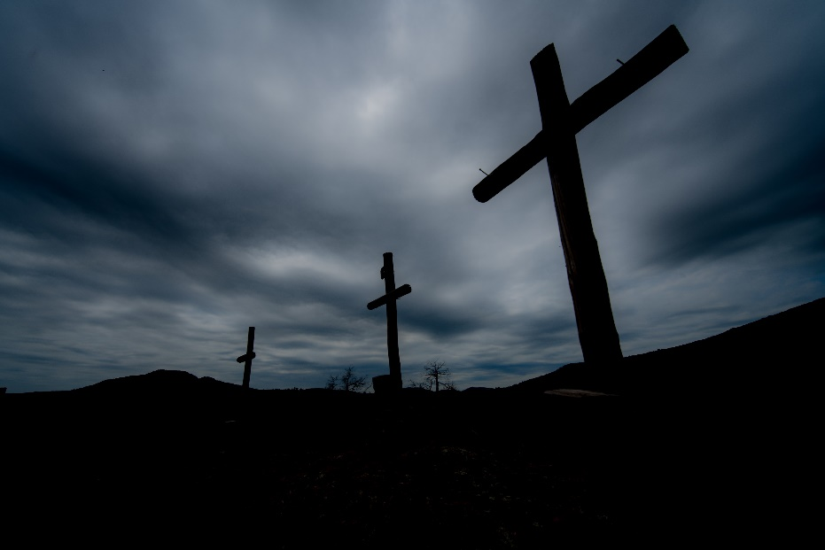

Scripture
One of the criminals who hung there beside him insulted Jesus, too, saying, “Are you really the Messiah? Then save yourself – and us!”
But the other answered the first with a rebuke: “Don’t you even fear God?” We are only paying the price for what we have done, but this one has done nothing wrong!” Then he said, “Jesus remember me when you come into your glory.”
Jesus replied, “The truth is, today you’ll be with me in paradise!” Luke 23: 39-43

Prayer
Jesus, who suffers with us,
grant that we may recognise Your gift of love in this time.
You reach out to us, even in the darkest hours.
May we, followers of your way in these lockdown days,
be able to reach through our pain,
to meet the needs of those around us,
whether it is with a word,
or a gesture,
or a prayer.
Amen.

Time of silence

Suggested music: Taizé chant
https://www.youtube.com/watch?v=5g6Q-uSV714

Jesus remember me,
when you come into your kingdom.

FOURTH STOPPING POINT – JESUS DIES

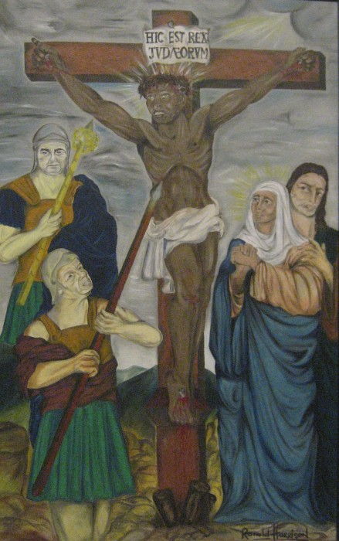
‘The Black Christ’ by Ronald Harrison

Scripture
It was about noon, and darkness fell on the whole land until three in the afternoon, because of an eclipse of the sun. Then the curtain in the sanctuary was torn in two, and Jesus uttered a loud cry and said, “Abba, into your hands I commit my spirit.”
Saying this Jesus breathed for the last time.
The centurion who saw this glorified God, saying, “Surely this one was innocent.” When the crowds that had gathered for the spectacle saw what had happened, they returned home beating their breasts and weeping. All the acquaintances of Jesus and the women who had come with him from Galilee stood at a distance, looking on. Luke 23: 44-49

Reflection
As you look into this painting of our South African Way of the Cross do you notice the familiar figures of
Chief Albert Luthuli as Christ crucified, surrounded by the two Roman centurions - prime minister, Hendrik Verwoerd, and justice minister John Vorster? Stay with these images awhile and the memories they evoke?
How does apartheid‘s legacy linger?
And now in this pandemic, how will different communities be so differently affected?

Time of silence

Suggested music: Senzeni na? sung by Cape Town Youth Choir
https://www.youtube.com/watch?v=5fDU1PYWT8A

Senzeni na?
(What have we done?)
Sohlangana ezulwini
(We will meet in heaven)

FIFTH STOPPING POINT - JESUS IS LAID IN A TOMB

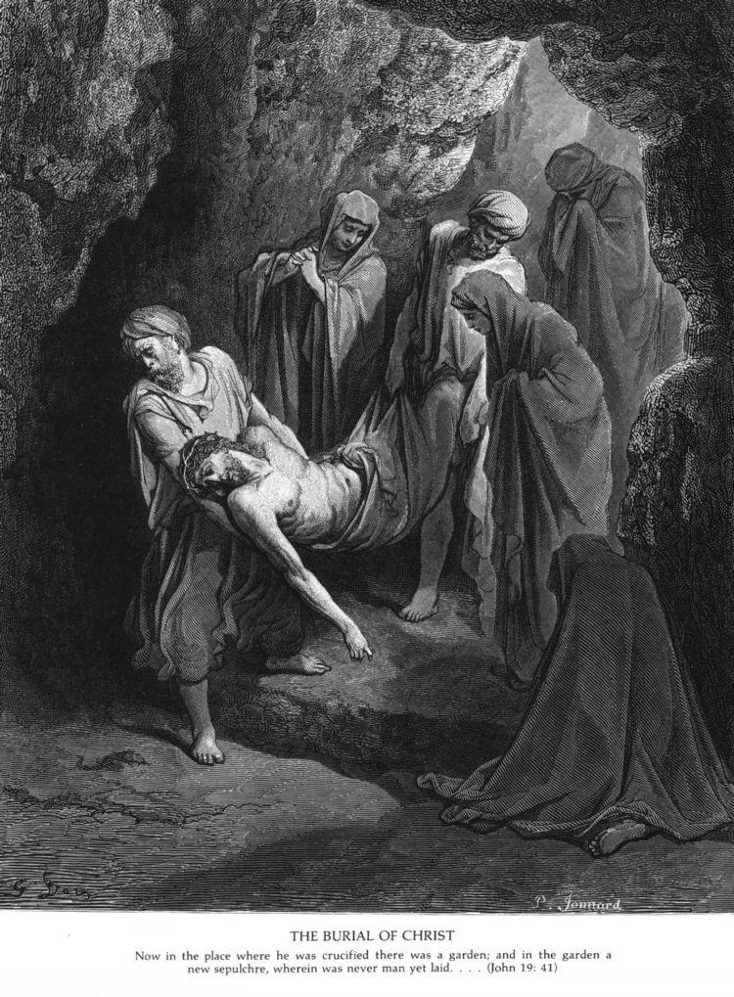
Wood cut by Gustave Doré. Obtained from http://catholic-resources.org/Dore/John19f.jpg

Scripture
After this, Joseph of Arimathea, a disciple of Jesus – but a secret one, for fear of the Temple authorities – asked Pilate for permission to remove the body of Jesus, and Pilate granted it. So Joseph came and took it away. Nicodemus came as well – the same one who had first come to Jesus by night – and he brought about one hundred pounds of spices, a mixture of myrrh and aloes. They took the body of Jesus and wrapped it with the spices in linen cloths, according to the Jewish burial custom.
There was a garden in the place where Jesus had been crucified, and in the garden was a new tomb where no one had ever been buried. Since it was the day before the Sabbath and the tomb was nearby, they buried Jesus there. John 19: 38-42

Reflection
Often we focus on the trials, torture and crucifixion of Jesus in reflections on Good Friday. Perhaps a less common stopping-point or station is captured in this passage from John. Secret disciples of Jesus choose to accord Jesus, crucified as a criminal, a dignified burial in a new tomb and they anoint his tortured body with costly spices before wrapping it in linen. How did these disciples feel at Jesus’ death? Why do they honour Jesus in this way? And what is the significance of time in the tomb for the body of Jesus?

As our world changes so much with the deaths and sickness of coronavirus, with economic hardships magnified by inequality in our society, we mourn and feel deep pain. We long for a time when this is over and we can rise again. Perhaps we, like Jesus, need time to be still, to be loved and to take a Sabbath rest, tomb time.

TOMB TIME
There is a time
between suffering
and rising
a pause

it may be
a day
or
a night
or
an hour

a time
to be still
tended
wrapped
perfumed

a time
for others to care
to hold
to embalm

the pause
the space between

be still
and know
that God is there
before the rising
behind the stone
in the dark

and you,
as you open
to Love
your spirit will quicken again

Time of silence

Suggested music: Deeper I Surrender by Ahria
https://youtu.be/MJf2NrTALVM

Deeper and deeper I surrender
Deeper and deeper I surrender to this love
Deeper and deeper I surrender
Deeper and deeper I surrender to this love

There is nowhere I have to go
No one I have to be
Nothing I have to do
But gently breathe, breathe, breathe

Deeper and deeper I surrender
Deeper and deeper I surrender to this love
Deeper and deeper I surrender
Deeper and deeper I surrender to this love

There is nothing I need to hold on to
Nothing I need to give to you
Nothing I need to do
But gently breathe, breathe, breathe.

Music interlude

There is nowhere I have to go
No one I have to be
Nothing I have to do
But gently breathe, breathe, breathe

There is nothing I need to hold on to
Nothing I need to give to you
Nothing I need to do
But gently breathe, breathe, breathe

Deeper and deeper I surrender
Deeper and deeper I surrender to this love
Deeper and deeper I surrender
Deeper and deeper I surrender to this love

Concluding prayer: A Lament
On 21 March 2020, Richard Rohr wrote in his Daily Reflection:
“We need to be reminded that our cries are not too much for God. [God] laments with us. In fact, [God] wants us to come to the [Divine Presence] in our anger, in our fear, in our loneliness, in our hurt, and in our confusion.”

There are many psalms of lamentation in the Bible, including Psalm 22, from which verses are often read on Good Friday. You may like to read this psalm as an example of such a prayer.

As you conclude your Way of the Cross and gather some of the emotions that have arisen during your meditation, perhaps you would like to create your own prayer of lament with the structure Richard Rohr describes.

- Laments begin with a complaint. . . that things are not as they should be.
- They turn to a request. God, do something! Rescue me! Heal me! Restore me! Show mercy!
- Laments end with an expression of trust. Laments end with the reminder that God is setting things right, even though it often seems so slow. It is right for our laments to turn towards a reminder that God is in control and about the business of righting all things made wrong.”

When you have finished, pray your Lament - aloud or silently, as you wish.

To conclude, take some deep breaths in and out, and end your Way of the Cross.

Prepared for the Open Table Community by Sarah Rule with Mary Ryan, April 2020

RESOURCES
Padraig Ó Tuama. (2017). Daily Prayer with the Corrymeela Community. London: Canterbury Press.
Jan Richardson. (2015). Circle of Grace. Orlando, Florida: Wanton Gospeller Press.
Richard Rohr Meditation: A Lament Practice for a Time of Crisis: Weekly Summary. 21st March 2020. From WeeklySummary@cac.org

